|  |  |
| --- | --- |
|  | **MATHEMATICS METHODS UNIT 3 & 4**  **TEST 5 2018**  **Calculator Free** |

Name: _____________________________

Reading Time: 2 minutes

Total Marks: 23 marks Time Allowed: 23 minutes

**Question One: [2, 3 = 5 marks]**

Consider the probability density function drawn below:

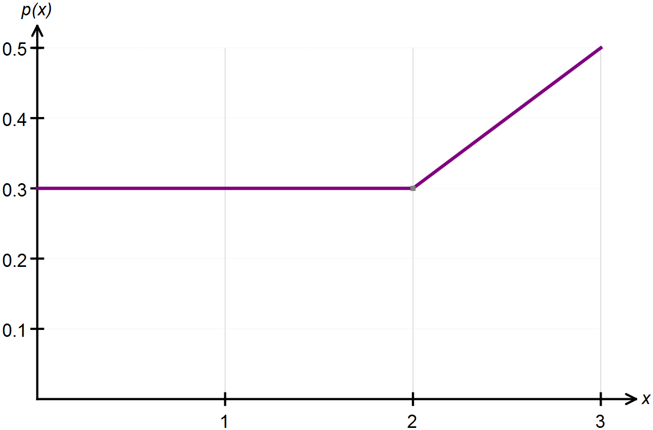

(a) Confirm, with appropriate calculations, that this above graph represents a probability density function.

(b) State the piecewise function that defines this continuous random variable.

**Question Two: [4 marks]**

Determine the value of k if represents a probability density function.

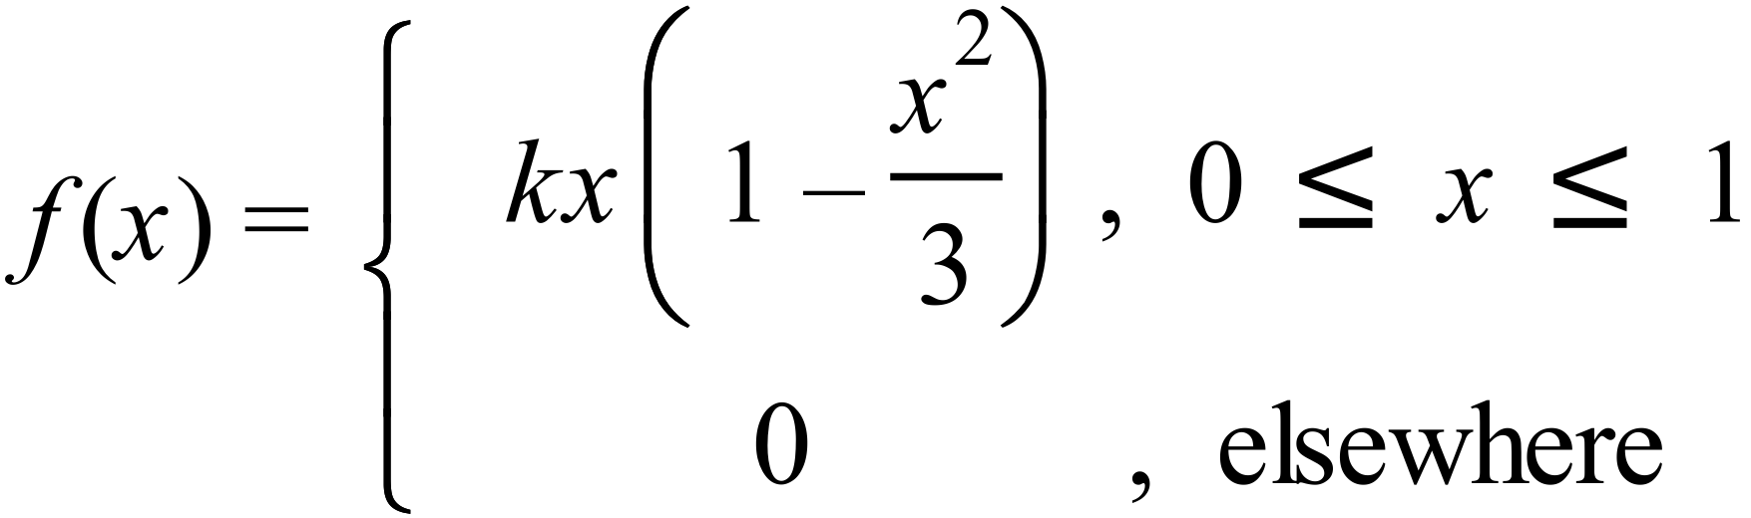

**Question Three: [4 marks]**

On a recent test, Tom scored 70% and his standard score was 1. Jerry sat the same test and his standard score was -0.5 when he scored 55%.

Calculate the mean and standard deviation for these test results.

**Question Four: [2, 2, 2, 2, 2 = 10 marks]**

The heights of fairy penguins in a particular geographic location are normally distributed with a mean height of 32 cm and a standard deviation of 1.5 cm.

Use the 68%, 95% and 99.7% rule to calculate each of the following.

(a) Determine the probability that a randomly selected fairy penguin is taller than 30.5 cm.

(b) Determine the probability of a randomly selected fairy penguin being shorter than 30.5 cm if it is known that they are in the 0.5 quantile.

(c) In a sample of 2000 penguins, how many would you expect to be taller than 35cm?

(d) What is the maximum height of the shortest 2.5% of penguins in this location?

(e) In a different geographic location the mean height of the fairy penguins found there is 33 cm. If 97.5% of the penguins are shorter than 35cm, and their heights are also normally distributed, what is the standard deviation for this population?

|  |  |
| --- | --- |
|  | **MATHEMATICS METHODS UNIT 3 & 4**  **TEST 5 2018**  **Calculator Assumed** |

Name: _____________________________

Reading Time: 3 minutes

Total Marks: 38 marks Time Allowed: 40 minutes

**Question Five: [1, 2, 2, 2 = 7 marks]**

A continuous random variable is uniformly distributed in the interval 3 ≤ *X* ≤ 9.

**(a)** Determine P(*X* < 5).

**(b)** Determine P(*X* < 5 | *X* < 6).

**(c)**  Calculate the mean and standard deviation of *X*.

**(d)** If *Y* = 2*X* + 5, determine the mean and standard deviation of *Y*. (2 marks)

**Question Six: [1, 1, 3, 2, 3 = 10 marks]**

A logging company makes logs of length X metres.

The values of X are normally distributed with a mean of 3.5 and a standard deviation of 0.2.

(a) Find the probability that the length of a randomly chosen log

(i) is exactly 3.5 metres.

(ii) exceeds 3.2 metres.

(iii) is less than 3.5 metres given that it is at least 3.2 metres long. Include a clear illustration with

your working.

(b) The probability of obtaining a log with a length of no more than $m$ metres is 0.8.

Show how to determine $m$.

(c) To improve the consistency of the length of the logs, the company decides to reduce the proportion of

logs exceeding 3.7 metres, to 10% while maintaining the same mean. Determine the new standard

deviation, stating your answer to the nearest centimetre.

**Question Seven: [2, 2, 1, 3 = 8 marks]**

(a) State the 30th percentile for standard normal distribution.

(b) Given that $X$ is a normal random variable with mean of 16 and a standard deviation of 3, determine the value of $k$ for which $(X+1>3k)=0.6$.

(c) Explain the following statement in terms of $μ$ and $σ$.

*A standard score of 2.4 has a corresponding x-value of 6.*

(d) When X has a probability density function, $f\left(x\right)=3x^{2}$ for $0<x<1$, determine the cumulative distribution function $F(x)$.

**Question Eight: [2, 2, 1, 3 = 8 marks]**

The mass, $X$ g, of wasted metal when a cast is made is a random variable with probability density function given by

$$f\left(x\right)=\left\{\begin{matrix}\frac{2x}{a^{2}} & 0≤x≤a, \\ & \\ 0 & \text{elsewhere},\end{matrix}\right.$$

where $a$ is a positive constant.

(a) Determine $E{(X)}$ in terms of $a$.

(b) The total mass of wasted metal from a random sample of 40 casts was 960 g. Estimate the value of $a$.

(c) If $a=12$, determine

1. $P(X≥4)$.

(ii) $\operatorname{Var}{(X)}$.

**Question Nine: [2, 2, 3 = 7 marks]**

The lifetime, $T$ years, of a make of radio transmitter is a continuous random variable with probability density function given by

$$f\left(t\right)=0.08e^{-0.08t}, 0≤t<∞.$$

(a) Determine the probability that a randomly chosen transmitter has a lifetime of less than $20$ years.

(b) A company buys $18$ transmitters. If they operate independently of each other, determine the probability that at least $15$ of them will have lifetimes of less than $20$ years.

(c) A transmitter has already been operating for exactly 21 years. Determine the probability that it will **not** fail within the next year.